Valley of the Rogue State Park: This is a nice park but an interesting choice for me to include with this guide. It’s an interesting choice, because it is too close to the freeway so I would not normally park here. The spaces pictured below, however, are far enough from the freeway to be very pleasant. Yet, that’s the reason I’m including it. There are many campers who would prefer to be next to the freeway for a quick off and park, then quick on and go the following day. If you are one of those campers, then this is a wonderful park. You will be 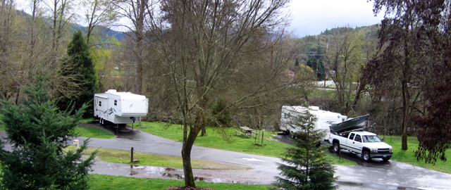 parked next to the Rogue River in a country setting but only 3 minutes to the Interstate-5 on-ramp. This is the area of southern Oregon where the Applegate Trail route and 1857 Gold Rush routes passed. The park maintains an interpretive kiosk to describe the two periods. Other activities within walking distance are a hiking trail and paved campground roads for bicycling. There are three separate campground opportunities. Two have full hookups while the third has water and electricity only. Laundry facilities and WI-FI are also available at this state park.
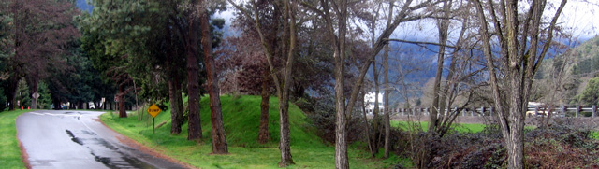
The park is separated from Interstate 5 by a large, grassy mound of dirt. You can see the mound in the photo above in the trees. The camping is located to the left of the photo. The furthest a camper would be from the freeway is approximately 300 yards. The two campers you see in the above photo are about that distance from the freeway and I doubt they will hear much traffic over the sound of the Rogue River just behind their campers.

Valley of the Rogue State Park Driving Directions: Take exit 45B from Interstate 5, the park is on the south side of the Interstate.

Webpage: http://www.oregonstateparks.org/park_109.php
Day Use: Open all year, no day-use fee.
Nearest Golf Course: Laural Hill Golf Course is only 7 miles south on Interstate 5. Take exit 40, Laural Hill Golf Course is on the south side of the freeway.
Campground: 147 mostly full hookup camp sites, some pull through spaces, ample space and 50 amp electrical service, asphalt parking.
Fees: Please check the Website for fees.
GPS Coordinates: 42° 24.66N 123° 8.9166W



