The Best RV Camping in Southern Oregon
By Dale and Gwen Prohaska, Escapee #91592
Our Fulltime RV Adventure, visit RVeCafe.com
©Copyright 2007 by Dale Prohaska

Gwen and Dale have assembled a list of RV parking locations in southern Oregon. These locations may not be advertised effectively or are just known by the local residents. Whether they are advertised or not, these are the camp sites Gwen and Dale would choose. They prefer quiet locations which are pet friendly so you will not find RV parks located next to a freeway listed here. Each listing begins with the reasons Dale and Gwen prefer this location and what they like best about the camp site.

Emigrant Lake Recreation Area: This is a very well maintained Jackson County park about 6 miles east of Interstate 5 from Ashland. It is an especially nice park during the summer months if you are traveling with children because there is a 280 foot water slide at the park. Other attractions within walking distance are a wonderful children’s play area, swimming beach, hiking trails, viewing wildlife and watching the Ashland Rowing Club practice on the lake. The RV park has full hookups but no shade trees so it can get pretty hot during the summer months.

Webpage: http://www.jacksoncountyparks.com/emigrant_lake.htm
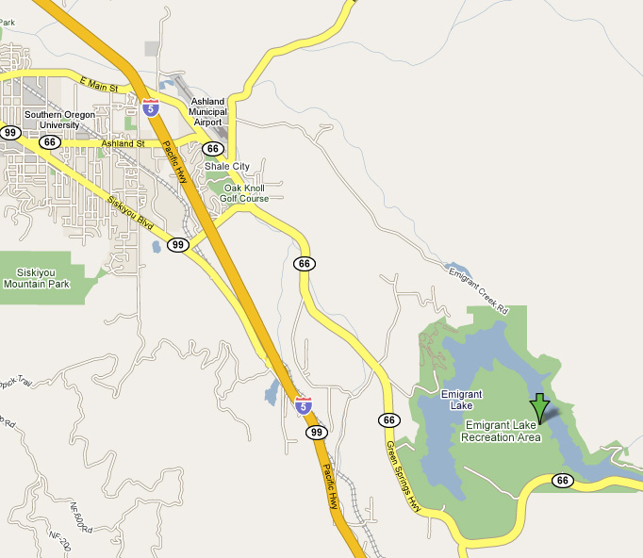
Day Use: Open year round 7:30am to sunset March 15 to October 15
7:30am to 5:00pm winter months
Campground: First Come First Serve - March 15 to October 15
Date may vary - call Park (541) 774-8183 for current information
Waterslide: Open the Saturday of Memorial Day Weekend through Labor Day
See: http://www.jacksoncountyparks.com/fees.htm for water slide fees.
The RV Park: Mar. 15-Oct. 15; date may vary - call (541) 774-8183 for current information
Lake Capacity: 40,500 acre-ft.
806-acre surface area.
Fees: Please visit the Webpage for current fees. GPS Coordinates: 42° 9.61 N 122° 36.87W

Emigrant Lake Driving Directions: Exit Interstate 5 at the Ashland/Klamath Falls exit number 14. Turn east (away from the city of Ashland) onto Highway 66 (yes this is Route 66, but not the same as the famous Route 66 to Chicago). Drive about 5 miles to the Emigrant Lake, Jackson County Park. Turn left into the park and campgrounds.

